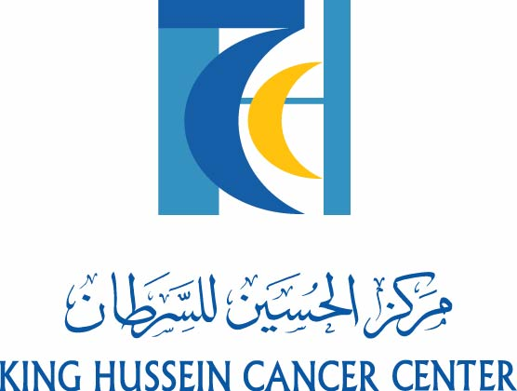

4th MEETING OF THE MEDITERRANEAN TASK FORCE FOR CANCER PREVENTION AND EARLY DETECTION
November 2nd, 2007
Dead Sea - Jordan

AGENDA

Thursday November 1st, 2007
Dinner at the Kempenski Hotel – Dead Sea

Friday November 2nd, 2007
9:00 – 9:15 Welcome by HRH Princess Ghida Talal

9:15 – 9:30 Welcome and Introduction
(M. Sarhan, Jordan)
(Z. Sharaiha, Jordan)
(S. Iacobelli, Italy)

9:30 – 9:45 Coffee Break

9:45 – 10:15 Reports by President (S. Iacobelli, Italy), Secretary General (M. Crespi, Italy), Treasurer (A. Montori, Italy)

10:15 – 10:45 Reports on the implementation of National Chapters
(by Delegates)

10:45 – 11:15 Report on the questionnaire sent to Members on the existing National Oncological Facilities
(M. Crespi, Italy)

11:15 – 12:00 Prayer Time (Free time)

12:00 – 12:30 Proposals for national countries public initiatives aimed to cancer prevention, screening and early diagnosis acknowledges by MTCC
(by Delegates)

12:30-13:00 Funding opportunities by the EU
(S. Iacobelli, Italy)

13:00 – 14:30 Lunch

14:30-15:00 The Values of Specialized Cancer Center; the Jordanian Experience
(M. Sarhan, Jordan)

15:00- 15:20 The Activities of the Portuguese League against Cancer: an example to follow
(M. Bernardo, Portugal )

15:20 -15:40 Cost Effectiveness of Cancer Screening
(E. Ghandour, USA)

15.40 - 16:00 The Cost of Treating Cancer: Where to draw the line?
(I. Treish, Jordan)

16:00-16:20 A Mediterranean Cancer Registry for inflammatory T4 Breast Cancer
(S. Iacobelli, Italy)

16:20 - 16:30 Coffee Break

16:30 – 17:00 Identification of early markers of Breast Cancer
(PG Natali, Italy)

17:00 – 17:30 Possible project: Design and Implementation of clinical trials in adjuvant setting for breast and colorectal cancer
(S. Iacobelli, Italy and any other Delegate interested)

17:30 – 17:45 Date and Venue of next meeting
(proposals by Delegates)

17:45 – 18:00 Closing remarks

